JavaScript
Task(1-15)
1.Write a program that calculates the total price of 3 products.
Code:
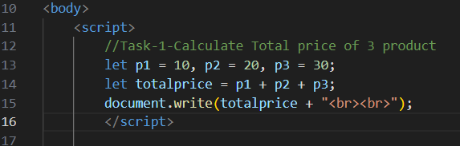
Output:
TotalPrice:
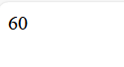
2.Create a script that checks if a number is even or odd using the modulus operator.
Code:
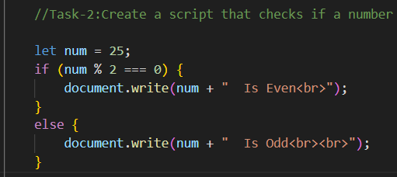
Output:
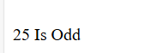
3.Write a program that increments a number from 1 to 10 using ++.
Code:
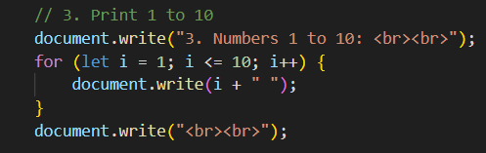
Output:
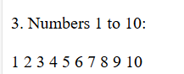
4.Check if a user is eligible to vote using comparison operators.
Code:
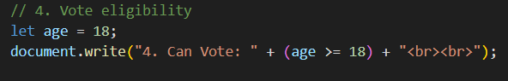
Output:
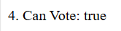
5.Write a program to compare two strings using == and ===.
Code:
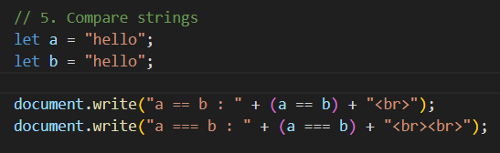
Output:
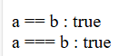
6.Use && to check if a user has a valid email and password.
Code:
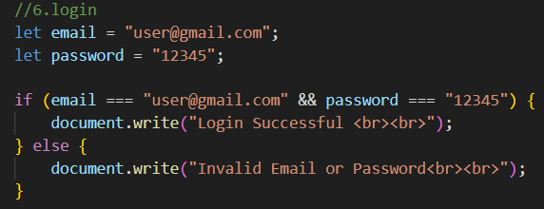
Output:
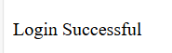
7.Write a program to update wallet balance using assignment operators.
Code:
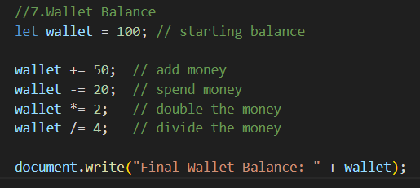
Output:
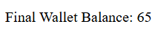
8.Use a ternary operator to check if a product is available in stock.
Code:
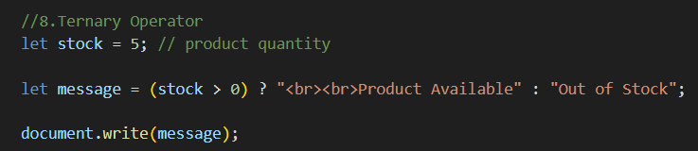
Output:
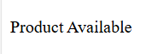
9.Create a simple "greater than" condition to compare two numbers.
Code:
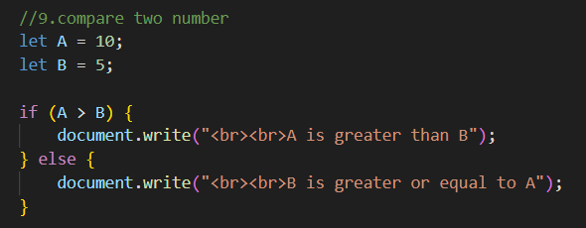
Output:
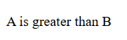
10.Write a JavaScript program to apply discounts if a cart total exceeds $50.
Code:
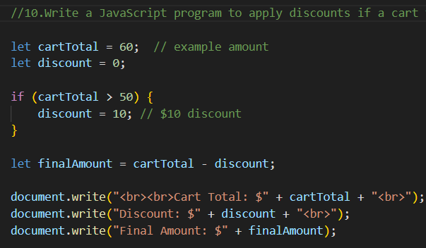
Output:
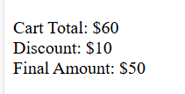
11.Use || to allow login using email or phone number.
Code:
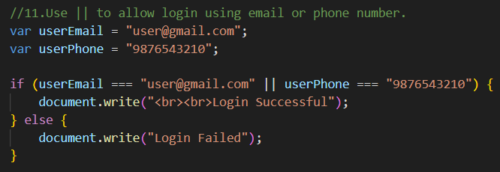
Output:
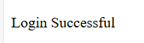

12.Implement a "Buy 1 Get 1 Free" condition using if and &&.
Code:
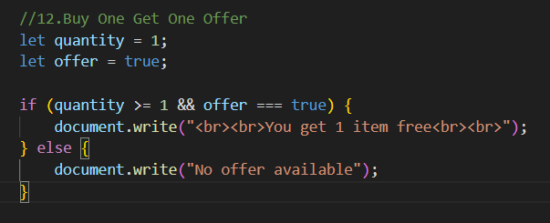
Output:
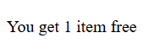
13.Check if a year is a leap year using the modulus operator.
Code:
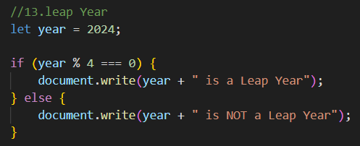
Output:
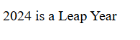
14.Use arithmetic operators to calculate the area of a rectangle.
Code:
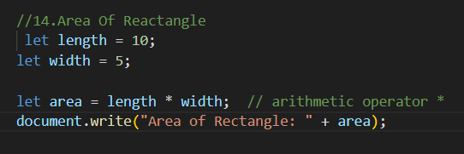
Output:
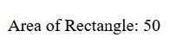
15.Check if a year is a leap year using logical and comparison operators.
Code:
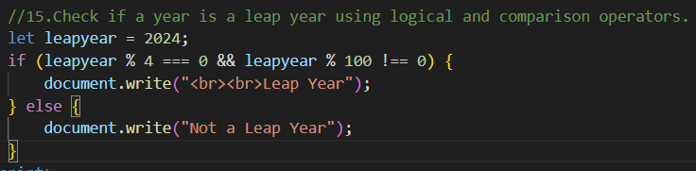
Output:
